Class Notes from January 8, 2022

- we began with the following paragraph as a review:
  - Guten Morgen! Frohes Neues Jahr! Ich heiβe ... (name).. Ich bin ... Jahre alt. Ich bin in ..(year).. in ...(city).. geboren. Ich wohne jetzt in ...(city).. Ich bin ... (marital status)... und habe ... Kinder.
    - to say the year you were born, formulate it by saying 19 hundred and the year. For example: neunzehnhundertneunundneunzig (1999) or neunzehnhundertachtundsechzig (1968)
- we then reviewed: family names/titles, how to make nouns plural
- we then began looking at vocabulary and new verbs for chapter 3
essen – to eat
möchten – would like
  - ich möchte
  - du möchtest
  - er/sie/es/man möchte **
  - wir möchten
  - ihr möchtet **
  - sie möchten
  - Sie möchten

trinken – to drink
  - ich trinke
  - du trinkst
  - er/sie/es/man trinkt
  - wir trinken
  - ihr trinkt
  - sie trinken
  - Sie trinken

  - ich esse
  - du isst **
  - er/sie/es/man isst **
  - wir essen
  - ihr esst
  - sie essen
  - Sie essen
kaufen – to buy
  - ich kaufe
  - du kaufst
  - er/sie/es/man kauft
  - wir kaufen
  - ihr kauft
  - sie kaufen
  - Sie kaufen

- we then talked about the use of ‘a’/’an’ in German ‘ein/eine’ and kein/keine
  - ein = a/an for masculine/neuter nouns
  - eine = a/an for feminine and plural nouns
  - kein = none for masculine and neuter nouns
  - keine = none for feminine and plural nouns

- to build sentences using the new vocab:
  - I have two apples. - Ich habe zwei Äpfel.
  - I have one banana. – Ich habe eine Banane.
  - I have no bananas. – Ich habe keine Bananen.
- we then went through the Lebensmittel handout and filled out the English vocab words (see below for attached)
- We then listened to the dialogue on pages 34 – 35
  - Ich habe Hunger. – I have hunger.
  - Ich bin hungrig. – I am hungry.
  - Was haben wir? – What do we have?
  - Wir haben nicht viel. – We do not have a lot.
  - Wir haben Milch, Butter, Zucker und Mehl. – We have milk, butter, sugar and flour.
  - Möchtest du Pfannkuchen? – Would you like pancakes?
  - Haben wir Eier? – Do we have eggs?
  - Wir brauchen Eier. – We have eggs.
  - Wo sind die Eier? – Where are the eggs?
  - zwei Euro neunundfünfzig – 2,59 €
  - drei Euro siebenundachtzig – 3,87€
  - Mist, mist, mist! – Poop, poop, poop
  - Kann ich dir helfen? – Can I help you?
  - lecker – delicious
- we then completed A1 on page 36

- HOMEWORK:
  - review the new vocab covered in class so far
  - try writing your shopping list in German

- NEXT CLASS:
  - we will be continuing on with chapter 3!

Lebensmittel - Groceries:
  - der Apfel – apple
  - die Äpfel – apples
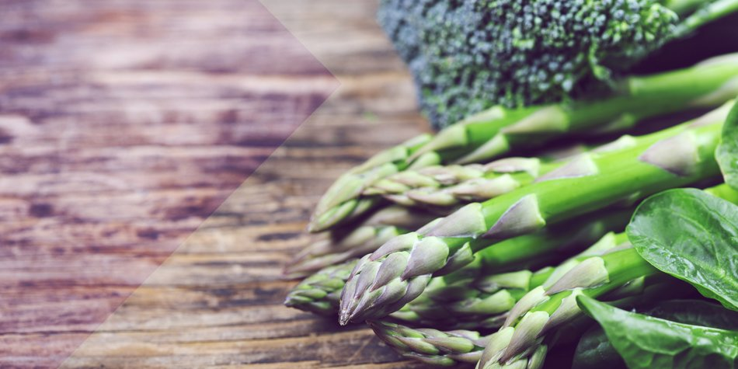
  - die Kartoffel – potato
  - die Kartoffeln – potatoes
  - der Kaffee – coffee
  - das Ei – egg
  - die Eier – eggs
  - die Banane(n) – banana(s)
  - die Orange(n) – orange(s)
  - der (die) Kuchen – cake
  - das (die) Brötchen – bun(s) or die Semmel(n)
  - die Tomate(n) – tomato(s)
  - das (die) Brot(e) – bread(s)
  - die Kiwi(s) – Kiwi(s)
  - die Wurst – sausage
  - die Würste – sausages
To make most nouns plural:
- if it ends in a consonant, add ‘e’ or ‘s’ (sometimes just ‘n’)
OR
- if it ends in e, add ‘n’
OR
- add an umlaut onto the first vowel
THEN
- change the article to ‘die’
  - der (die) Fisch(e)- fish
  - der (die) Joghurt(s) – Yogurt
  - die Traube(n) – grape(s)
  - der Saft – juice
  - die Säfte – juices
  - der (die) Tee(s) – tea
  - der Reis – rice
  - das Gemüse – vegetables
  - das Bier – beer
  - der Wein – wine
  - die Milch – milk
  - die Sahne – whipping cream
  - das Fleisch – meat
  - das Mineralwasser – sparkling water
  - das stille Wasser - still/tap water
  - das Salz – salt
  - der Pfeffer – pepper
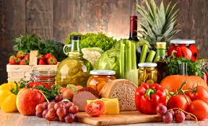
  - der Käse – cheese
  - das Obst – fruit
  - die Butter – butter
  - das Öl – oil
  - der Essig – vinegar
  - der Senf – mustard
  - der Korb – basket

